
Safety Bay Senior High School
Chemistry Unit 2

Test #5:
Intermolecular Forces
Solutions

NAME: ______________________________________

DATE: ______________________________________

Section | Mark
Multiple Choice | / 10
Short Answer | / 50
Total | / 60

Section 1: Multiple Choice (10 marks)
- Which of the following correctly arranges the compounds in order of increasing polarity of bond?

  - F₂ CℓF BrF IF
  - IF BrF CℓF F₂
  - CℓF BrF IF F₂
  - F₂ IF BrF CℓF

- Which of the molecules is non-polar but contains polar covalent bonds?

  - Oxygen, O₂
  - Sulfur dioxide, SO₂
  - Tetrachloromethane, CCℓ₄
  - Ammonia, NH₃

- For the substances C (graphite), O₂, C₃H₈ and C₂H₅OH, which of the following represents them in order of increasing melting point?

  - O₂ C₃H₈ C₂H₅OH C
  - C₃H₈ O₂ C₂H₅OH C
  - O₂ C C₃H₈ C₂H₅OH
  - O₂ C C₂H₅OH C₃H₈

- In general, what can be said about the surface tension and vapour pressure of substances which have particularly weak intermolecular forces?

  - Surface tension: High Vapour pressure: Low
  - Surface tension: High Vapour pressure: High
  - Surface tension: Low Vapour pressure: Low
  - Surface tension: Low Vapour pressure: High

- Which type of bonding is NOT present in solid hydrogen chloride (HCℓ)?

  - Covalent
  - Dipole-dipole
  - Dispersion force
  - Hydrogen bonding

- The boiling point of a family of trihalomethanes (CHX₃) are listed below:

Trifluoromethane CHF₃ -89 °C
Trichloromethane CHCℓ₃ 61 °C
Tribromomethane CHBr₃ 150 °C
Triiodomethane CHI₃ 330 °C

The increase in boiling points moving down the list is due to an increase in the strength of:
  - Covalent bonding
  - Dispersion forces
  - Dipole-dipole bonding
  - Hydrogen bonding
The next two questions refer to the following graph showing the solubility of two substances over a range of temperatures.

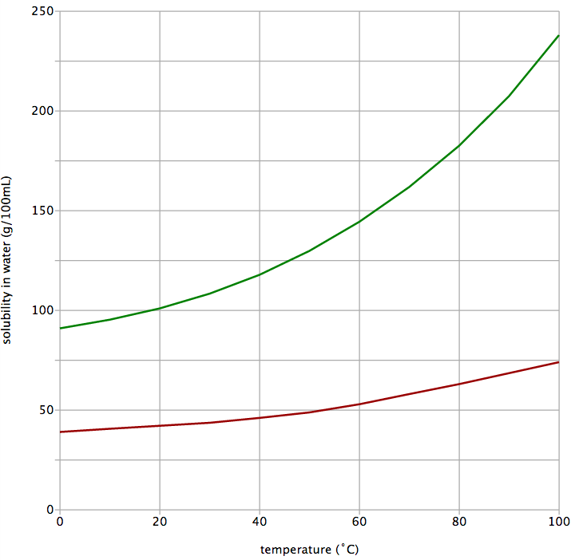
III

II

I

Copper(II) sulfate
Potassium nitrate

- If you initially had 50 g of potassium nitrate dissolved in 300 mL of water at 20 °C, how much additional potassium nitrate would you be able to dissolve in this solution?

  - 50 g
  - 100 g
  - 250 g
  - 300 g

- Which point of the graph represents a supersaturated solution of copper(II) sulfate??

  - Point I
  - Point II
  - Point III
  - This cannot be determined without knowing the volume of water

- The concentration of sodium hypochlorite, NaCℓO, in White Cling hospital-grade disinfectant is 52.5 g L⁻¹. A company wished to produce 500 two-litre bottles of the disinfectant.

Which of the following formulas correctly calculates the mass of sodium hypochlorite needed by the company?

  - $m\left(NaClO\right)=\frac{52.5 × 2}{500}$
  - $m\left(NaClO\right)=\frac{52.5 × 500}{2}$
  - $m\left(NaClO\right)=52.5 × 500 × 2$
  - $m\left(NaClO\right)=\frac{52.5 }{500 × 2}$

- Consider the following TLC plate of compounds X, Y and Z developed using a non-polar mobile phase on a polar stationary phase.
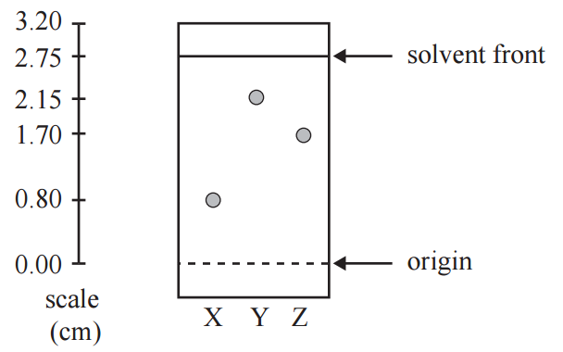

The R_{f} value of the most polar component in this TLC separation is:
  - 0.29
  - 0.78
  - 0.80
  - 2.15

Section 2: Short Answer (50 marks)

For each of the species listed below:
- draw the structural formula, representing all valence shell electron pairs as : or as – (3 marks)
- draw and name the shape of the molecule (3 marks)
- state the polarity of the molecule (3 marks)

Species | Structure (showing all valence shell electrons) | Drawing  of shape | Name  of shape | Polarity of  molecule  (polar or  non-polar)
Water  (H₂O) | ··  H — O — H  ·· | O  H H | Bent | Polar
Carbon disulfide
(CS₂)
Phosphorus tribromide
(PBr₃)
Difluoromethane
(CH₂F₂)

Compare the vapour pressure and density of liquid water to the other named substances. Justify the reasoning behind your prediction, using diagrams where appropriate.

- Compared to pentane (C₅H₁₂), the vapour pressure of liquid water is: (3 marks)

higher equal lower

Explanation:

- Compared to solid water (ice), the density of liquid water is: (4 marks)

higher equal lower

Explanation (including a supporting diagram):

Diagram:

Formaldehyde is a toxic chemical used in the production of resins. It has the molecular formula of CH₂O. The structure of formaldehyde is shown below:
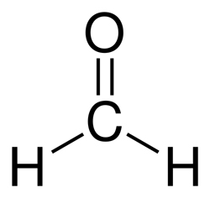

- On the above diagram, show the ‘lone pairs’ of electrons possessed by this molecule. (1 mark)

- Explain why formaldehyde has the trigonal planar shape represented in the image above.
(2 marks)

- Formaldehyde is described as a ‘polar molecule’. Explain why this is so. (3 marks)

- Salts such as sodium chloride dissolve in polar solvents like formaldehyde. Name the type of attractive force that allows sodium chloride to dissolve in formaldehyde. (1 mark)

For each of the following molecule pairs:
- Circle the molecule with the highest boiling point
- Give a brief explanation for your choice

- carbon dioxide (CO₂) OR sulfur dioxide (SO₂) (3 marks)

Explanation:

- bromine (Br₂) OR iodine (I₂) (3 marks)

Explanation:

Paracetamol is a commonly used painkiller. The partial equation below shows one method of preparing paracetamol.

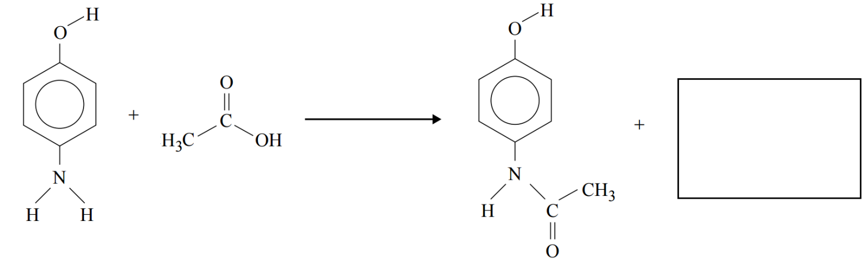4-aminophenol ethanoic acid paracetamol

- Complete the equation above by showing the formula or structure of the other substance formed during this reaction. (1 mark)

- Explain in terms of intermolecular forces, whether you would expect paracetamol to be soluble in water. Include a diagram showing interactions between paracetamol and water molecules. (4 marks)

Diagram:
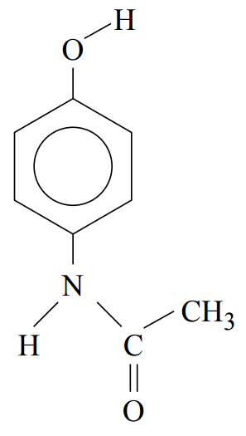

On Earth, water evaporates, forms clouds and falls back to the ground in a process known as the ‘water cycle’.
On Saturn’s moon Titan, where the average temperature is -178 °C, methane (CH₄) behaves the same way as water does on Earth, evaporating and raining onto the surface as a liquid.
Using your knowledge of their structure and bonding, explain why water and methane undergo these processes at such different temperatures. (4 marks)

Write balanced ionic equations for the following reactions. If no reaction occurs then you should state ”no reaction” for the equation. For each situation give a full set of observations which describe what is observed when the chemicals are mixed. (5 marks)
- Nickel(II) nitrate solution is added to an excess of sodium phosphate solution.

Equation:

Observations:

- Copper(II) sulfate solution is added to a magnesium chloride solution.

Equation:

Observations:

Oxalic acid, H₂C₂O₄•2H₂O, is a toxic substance found in rhubarb leaves. Solutions of oxalic acid are used in the dying and bleaching industries.
What is the concentration, in mol L⁻¹, of an oxalic acid solution of 10.2 g of oxalic acid dissolved in 200 mL of solution? (2 marks)

A group of students wanted to measure the rate of reaction between magnesium and hydrochloric acid at different temperatures. The equation for the reaction is:
Mg + 2 HCℓ MgCℓ₂ + H₂
In order to avoid conflicting results, the students wanted to ensure that they had sufficient acid to react with all of the magnesium.
What volume of 0.1 mol/L acid would be required to completely react with 1 g strips of magnesium?
(3 marks)

Caffeine is a stimulant drug that is found in coffee, tea, energy drinks and some soft drinks. The concentration of caffeine in drinks can be determined using HPLC.
Four caffeine standard solutions containing 50 ppm, 100 ppm, 150 ppm and 200 ppm were prepared. 25 μL of each sample was injected into the HPLC column. The peak areas were measured and used to construct the calibration graph below. The chromatograms of the standard solutions each produced a single peak at a retention time of 96 seconds.

25 μL samples of various drinks though to contain caffeine were then separately pass through the HPLC column. The results are summarised below.
Sample | Retention time of  major peak (seconds) | Peak area of largest peak
Soft drink A | 96 | 12 000
Soft drink B | 32 | 8 500

- What is the concentration, in ppm, of caffeine in soft drink A? (1 mark)

- What evidence is presented in the chromatogram that supports the conclusion that soft drink B does not contain any caffeine? (1 mark)

